**Build and Deploy hadoop word count program using Gradle.**

For implementing Hadoop using gradle one has first install the gradle using

***sudo apt-get install gradle.***

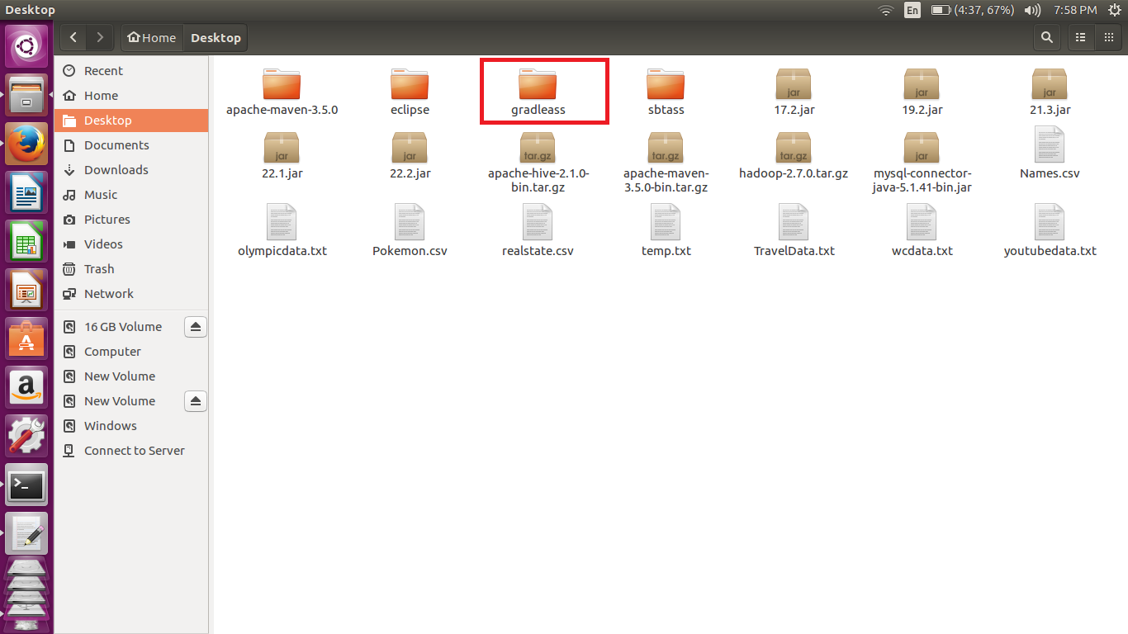

Similar to the sbt we have created the gradleass folder in desktop and in that we have created the src/main/java folders.

Now we have copied the the .java file into java folder that we have created. We can do it the other way round by importing gradle into eclipse and then editing the code in eclipse. As we have the error free code we can directly in the java folder.

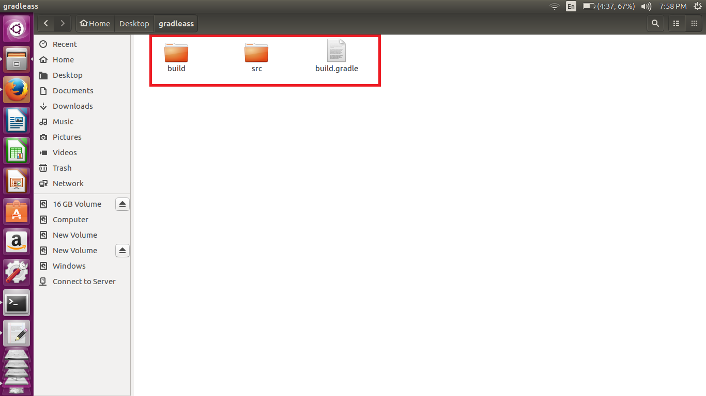

**Gradle build**

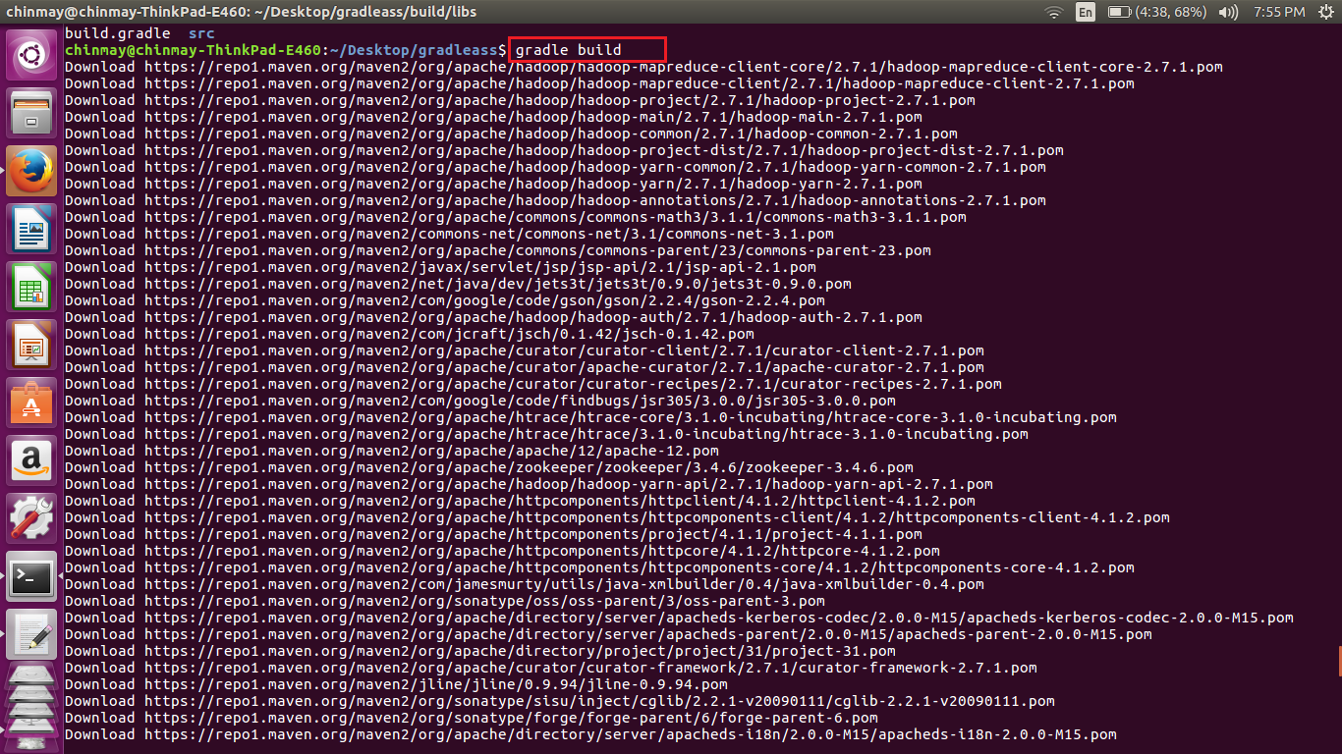

Now changing the directly where we have created the gradleass folder execute the command ***gradle build .*** This will generate a jar file in the target folder.

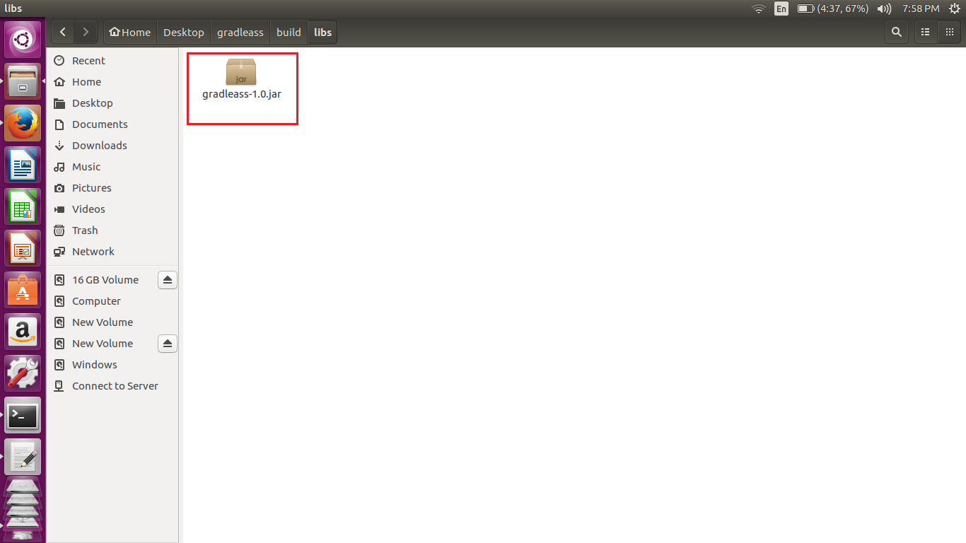

Now once we have created the jar file we can run the jar file

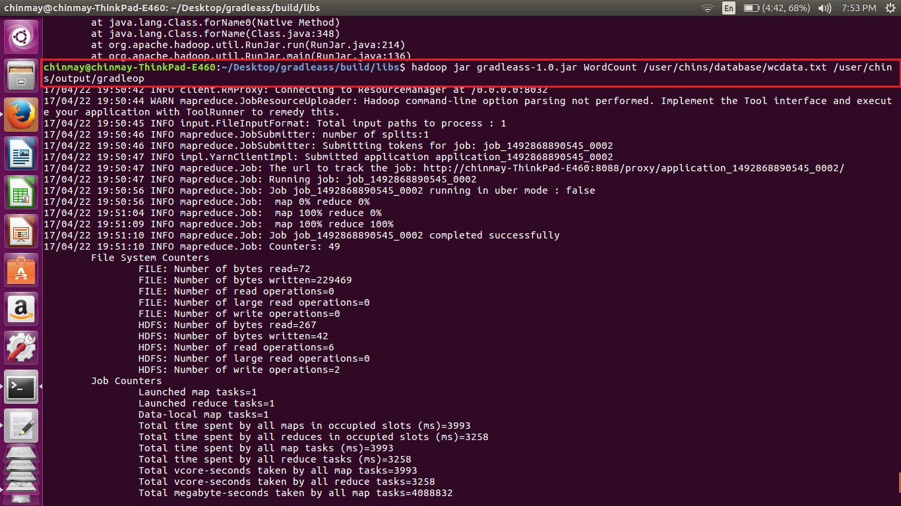

Here we have mentioned the input and the output path:-

**Output**

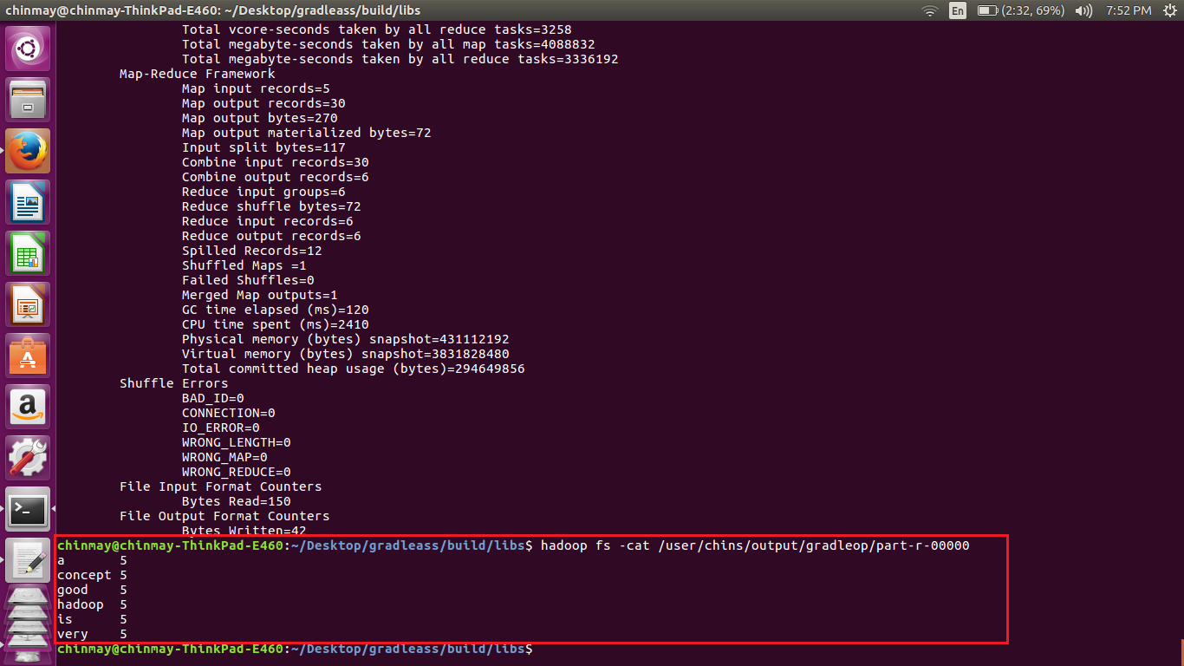

The input file had the given line

***Hadoop is a very good concept***

***Hadoop is a very good concept***

***Hadoop is a very good concept***

***Hadoop is a very good concept***

***Hadoop is a very good concept***

The word count program used for the implementation was

